|  |
| --- |
| Dr. USMAN ABBASI |
| Computer Organizational and Assemble language-LAB |
| Lab manual-2 |

|  |
| --- |
| Armghan Ahmad | 20P0183  10/7/2021 |



**Lab manual 2**

Objectives:

In this lab we had installed DOSBOX and NASM. We had also seen how we mount our drive. We also write a piece of code and debug it using nasm.

Step 1:

We download the software softweres.PNG

Step2:

Then we install the setup of **DOSBOX a**nd set the destination Folder.

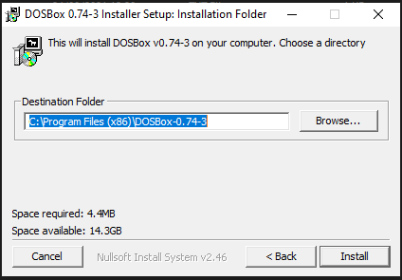

Step 3:

It will took few min or sec depending on system.

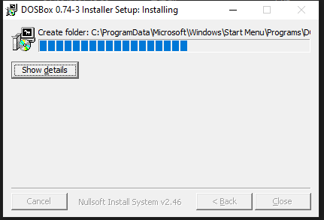

Step4:

After **DOSBOX** has successfully installed we will see shortcut icon on the Desktop.

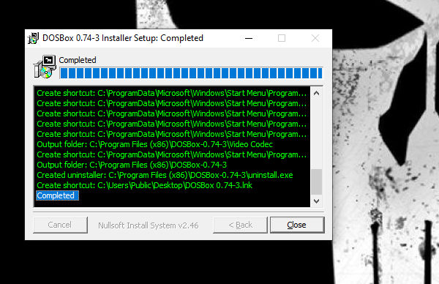

Step 5:

**DOSBOX** interface.

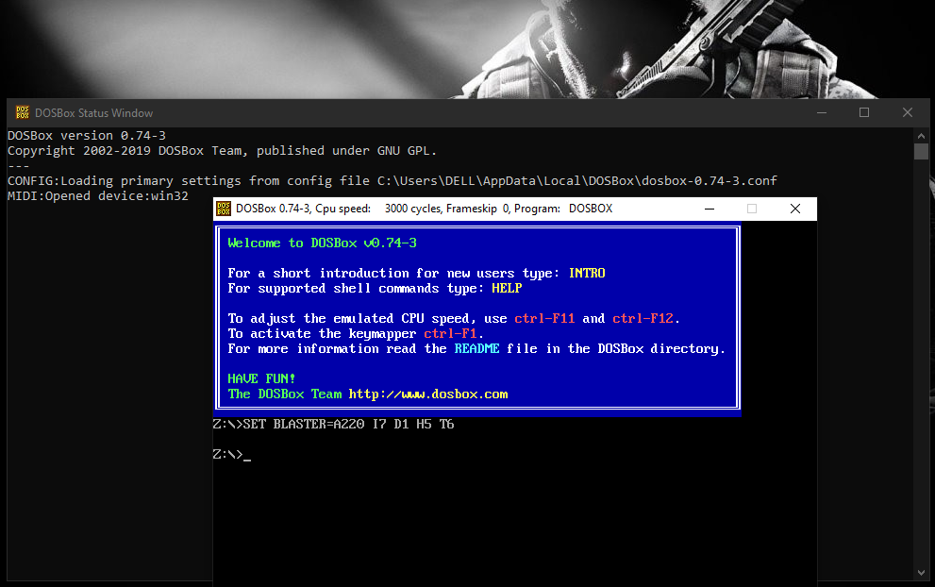

Step 6:

Mounting X as local directory. By typing “mount X home:/directory name”. e.g.:

mount x e:/Assembly

Our X is mounted as local directory successfully

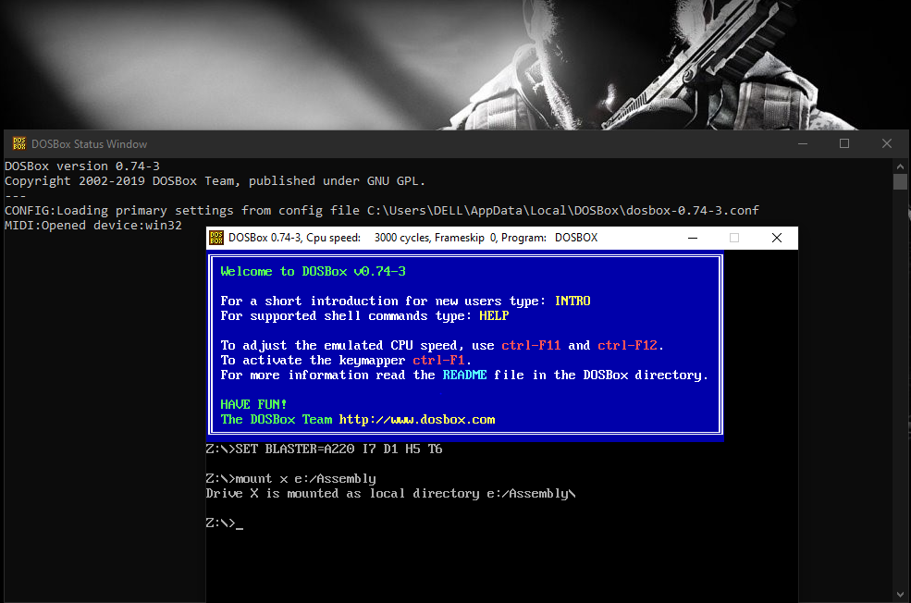

Step 7:

After the directory has mounted we will type **afd** for debugging.

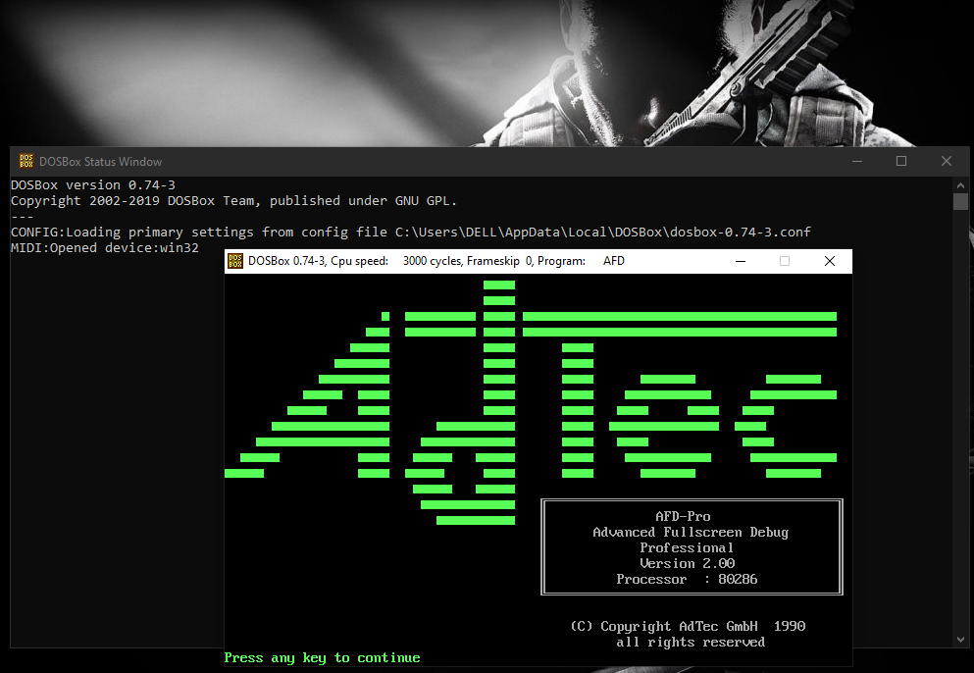

Step 8:

Debugging interface is

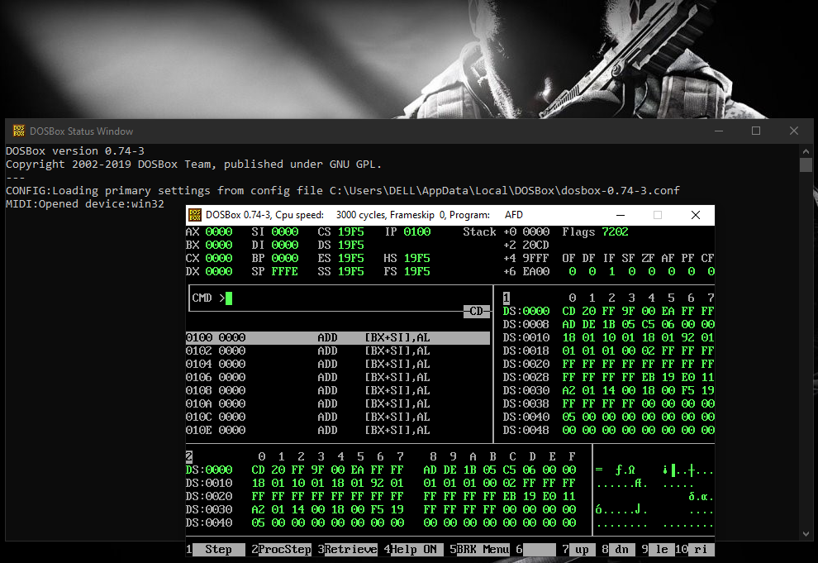

Step 9:

Now we will write the code in a file and then we will save the file as “.asm”. After that “.com”

Will be created. So the and we then simply type “afd file_name.asm –o file_name.com”

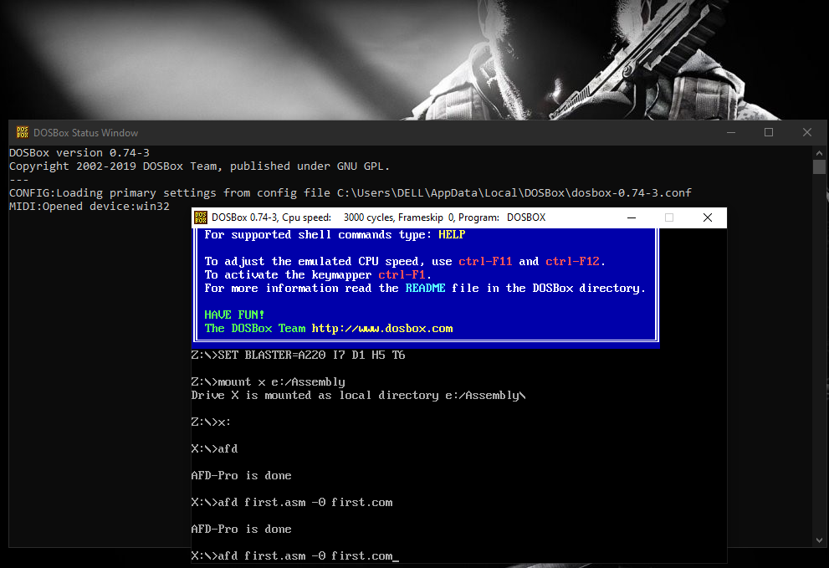

Step 10:

Debugging interface of the file is by just clicking “**F1**” and the commands will be run.

